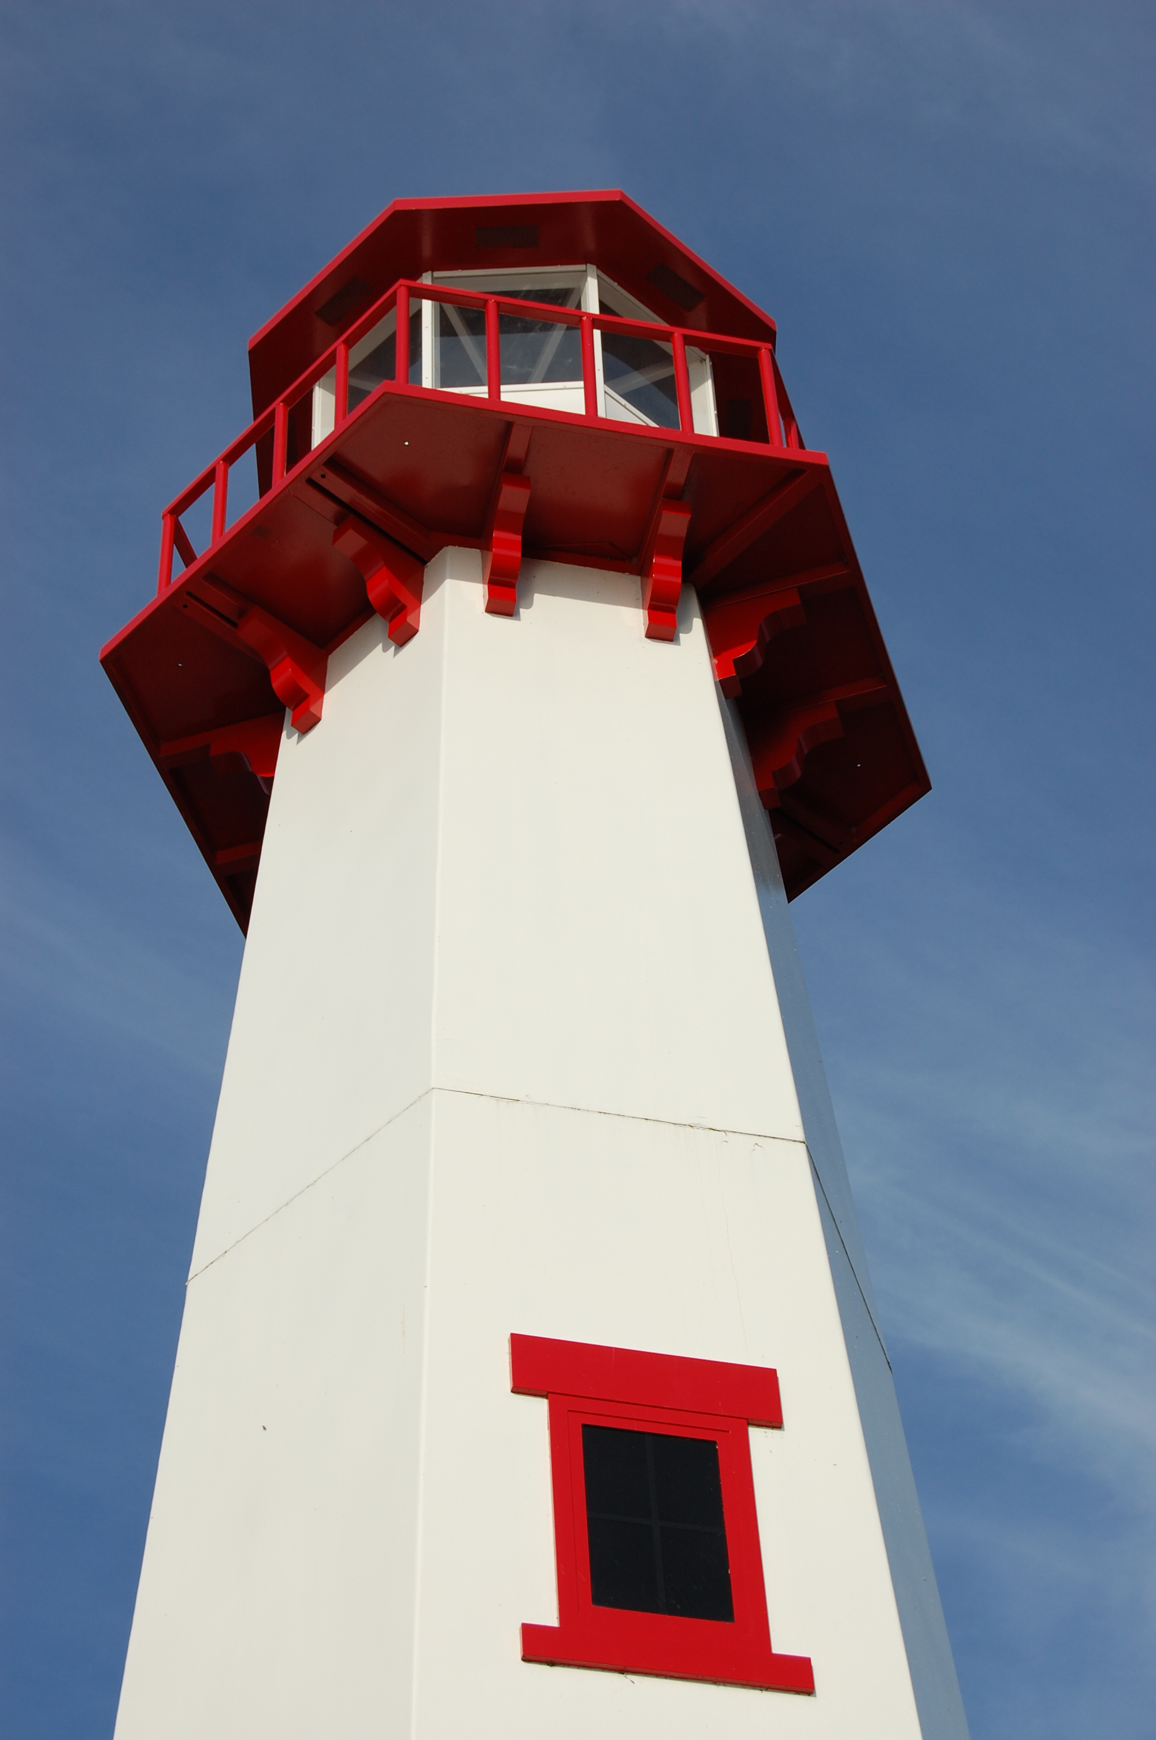
THE LIGHTHOUSE

Newsletter for August 2018

By day you led them with a pillar of cloud, and by night with a pillar of fire to give them light on the way they were to take.
Nehemiah 9:12

Message from our pastor

Dear Brothers and Sisters in Christ,

As we begin the month of August, there are two major aspects of being a community of faith that both Zion and Trinity will be really focusing on. Stewardship and Mission. Both are one in the same, without one you don’t have the other.
At Zion the focus will be the difficult situation we find ourselves finically. The Church Council and Endowment Committee have been working hard to address this situation, and we will be having a very important congregational meeting on the 5th of August after Church, where we can all sit down and discuss the situation, so please I really encourage you to attend this meeting, we are in this thing together. We will also begin work with a Synod project looking at church vitality, and how we create new energy with in our community of faith. You will see more about this in the weeks to come, so keep an eye out for something extra in the bulletin.
At Trinity we will begin to work with the Partners of Sacred Places, which is a foundation that is focusing on preserving and restoring churches with Nordic Heritage. But the exciting thing about this project is the education in stewardship and mission that comes along with the grant money that we could possibly receive.
During a recent training Jerri Rose and I attended for the Partners of Sacred Places program, we were asked 3 questions that I think both congregations need to look at and think about as we navigate our current journeys in Stewardship and Mission.
Who we are: What impact do we have on our communities? Not only do we as individuals have our own personal identities as children of God, the same goes for our churches. What is our identity? Does that identity come quick to mind, or do we have to think about? It’s ok to have to think about it, because by thinking about it together, through prayer and the work of the Holy Spirit we will begin to see the plan God has called us to do.
What we have: What are the gifts we have to share with the community around us? We all have gifts from monetary, time, the personal gifts God has given to each and every one of us, and the gift of the wonderful worship spaces both Zion and Trinity have to offer to the communities we belong in. How are we good stewards of all these gifts we have? How can use these gifts in the mission God has called us to do through our baptisms?
What we do: Now what is it that we do in our communities? Are there old things that need a tune-up? Or maybe we should let them go and look for something new? Mission is an ever changing and thing, what worked 10-20 years ago, might not today, so together we need to sit down and figure out how can we be good stewards with the gifts God has given us it this ever-changing world for the church, to love and serve our neighbors and each other? How do we go from worrying about the bills, (now don’t get me wrong, paying the bills is a very important aspect of mission) to doing what we are called to do as a community of faith?
This is a lot to take in and think about, so I’m going to stop right here for now, but I know we will be talking about it more in the days and months ahead. God has a plan for us, we just need to pray, talk to each other, and trust the Holy Spirit to guide us there.
Yours in Christ,
Pastor David

Newsletter

The Newsletter for August was not adopted. ☹

Noisy Offering

The August Noisy Offering will go to
the Project Backpack.

Important Zion Congregational Meeting

August 5, 2018

Zion's Church Council met on July 18, and we determined that we need to hold a full Congregational meeting following the service on August 5, 2018. The meeting is very important as we will be discussing the continuing decline in Church finances. At the meeting, Council will discuss in more detail where we are financially and we will ask the Congregation to review, discuss, and vote on a proposal to use some of the Mission Endowment Fund to help pay for operational expenses that currently are not being met. Please plan on attending this very important meeting to share your thoughts.

Thank you,
Zion Lutheran Church Council

Adult Bible Study

Trinity Bible Study will be Tuesdays at 6 pm.

Vacation Bible School 2018

Vacation Bible School “God’s Good Creation” will be held
from 6 pm – 8 pm at Zion Evangelical Lutheran Church in St. Ignace, from August 5th thru 8th. There will be Dinner, worship, crafts and games. All children going into K – 6th grade are welcome! (We’re looking for volunteers, if you’re interested contact Pastor David.)



Anniversaries in August

August 3 Mike & Janet Herman
August 6 Mark & Carol Elmblad
August 6 Michael & Faith Gaubault
August 17 Bob & Debbie Brandstrom
August 17 Jon & Connie Olsen
August 23 Durance & Becky Paul
August 28 Charlie & Audrey Stenson
August 28 Les & Debbie Therrian

Birthdays in August

Aug 2 Amber Anderson
Aug 2 Molly Dandona
Aug 5 Cierra Barker
Aug 6 Joe Chalmers
Aug 6 Bailey Ryerse
Aug 7 Sandy Feleppa
Aug 8 Ethan Shepard
Aug 8 Craig Therrian
Aug 13 Tyler Chambers
Aug 14 Stephanie Jenkins
Aug 14 Lana Lennington
Aug 14 Dottie Glashaw
Aug 16 Cole Garen
Aug 17 Shari Baron
Aug 19 Haley Dodds
Aug 21 Matthew Rogers
Aug 22 Donovan Insley
Aug 23 Lisa Rogers
Aug 24 Nicole Garen
Aug 25 Kristine Vallier
Aug 26 Gary Sorenson
Aug 27 Les Therrian
Aug 28 Duane Gamble
Aug 29 Gunnar Olsen
Aug 30 Michael Gaubault
Aug 30 Jim Ryerse
Aug 31 Savannah Barker

Baptismal Anniversaries

August 1 Linda Wilkins
August 1 Dianne Nelson
August 10 Aubree Vallier

August 12 Debbie Therrian
August 18 Bob Brandstrom
August 18 Wendy McCluskey
August 20 Abby LaLonde

Evergreen Living Center

Barb Lehto
Judy Ryerse

Trinity Worship Families

Aug 5 Baron Family
Aug 12 Meeker Family
Aug 19 Chalmers Family
Aug 26 Kennedy Family

Zion Funeral Committee June-Sept

Team Leader: Lorraine Graham (643-8419)
Co-leader: Betsy Turf (643-1512)

~~~


7 days without prayer makes 1 weak.

Servants for Zion

Ushers & Greeters

Aug 5 Delores & Cliff Marshall
Aug 12 Matthew Valetta & Ray Wilkins
Aug 19 Sandy & Fred Feleppa
Aug 26 Tim & Sally Idalski

Lectors

Aug 5 Betsy Turf
Aug 12 Fred Feleppa
Aug 19 Richard Galor
Aug 26 Cathie Tielbar

Communion Assistants

Aug 5 Emma Feleppa
Aug 12 Tammy Shepard
Aug 19 Stevan Christiansen
Aug 26 Mary Christiansen

Altar: Susan Fenlon
Money Counters: Stevan & Mary Christiansen

The Usher duties are:
- Arrive 30 minutes before church
- Pass out bulletins and welcome guests
- Help with the offering and communion
- Record attendance

Council Meetings

Zion Council – August 13, 2018 – 6:30 pm

Trinity Council – August 21, 2018 – 6 pm

Zion’s Council Members
President: Steve Christiansen 298-1051
Vice-President: Carol Elmblad 630-4380
Co-Treasurers: Dawn Akers 643-7552
Co-Treasurers: Lana Lennington 643-6576
Mary Christiansen 235-6123
Robert Marshall 643-8936
Secretary Dena Barker 430-1460
Emma Feleppa 430-8011
Tammy Shepard 906-984-2064

Trinity’s Council Members
President: Jerri Rose 292-5570
Vice-President Sharon Chalmers 292-5440
Secretary: Tracy Movalson 292-5581
Treasurer: Pega Kennedy 292-5633
Co-Treasurer: Jim Rose 292-5570
Financial Secretary: Tom Gustafson 292-5460
WELCA: Pega Kennedy 292-5633
John Kennedy 292-5633
Lois Movalson 292-5581

Treasurer's Report for Zion
January 1, 2018 through July 21, 2018
Income:
 | Amazon Smile Foundation | 22.57
 | Building | 40.00
 | Church Use Income | 685.00
 | General | 27,760.44
 | Fund Raising | 2,519.77
 | Trinity Share | 6,658.11
 | TOTAL |  | 37,685.89
Expenses:
 | Administration | 3,185.73
 | Benevolence | -189.06
 | Church Maintenance | 7,368.54
 | Education | 275.45
 | Parsonage Maintenance | 1,950.51
 | Pastoral | 25,849.66
 | Worship | 1,910.12
 | --To Building Fund | 0.00
 |  |  | 40,350.95
 |  |  | -2,665.06
********************************************************
Thrivent Financial Investment Fund |  |  | 317.01
General fund balance: |  |  | -1689.83
Kitchen/Building Fund balance |  |  | 1923.63
General fund owes building fund: |  |  | $ 40.00
General fund owes Mission Endowment fund: |  |  | $ 7,995.00

Zion Lutheran Church

Council Meeting Notes

July 18, 2018

Council Members Present: Pastor Dave, Mary, Steve, Bob, Tammy, and Dawn

Steve called the meeting to order at 6:50 p.m.

Pastor opened with devotions and prayer.

Old Business:

A. Pastor's Report:

1. Vacation Bible School will be here at Zion, assisted by the Methodists, starting Sunday August 5 thru Wednesday August 8. Times are 6-8 p.m. each day. Planning meeting scheduled for July 19. We will need help.

2. Saturday Evening Services were held the first 2 Saturdays in July with 10 attending the first night and 0 the second night. Saturday Services are scheduled for July 21 and 28 at 6:30 p.m.

B. Treasurer's Report:

1. Dawn presented the Treasurer's report and we are still badly in need of increased revenue. Pastor received only half a check again last payday, we are behind on payments for his social security and we have not paid anything toward our 2018 commitment of $3,000 to the Synod. Our weekly giving is averaging $600 to $700 and is not sufficient to meet expenses for the short or long term.

2. After discussion we decided to start the process of using some of the Mission Endowment Fund to catch up on shortfalls and augment our budget to meet future needs. There is a clause in the Endowment Bylaws that would allow this with Congregational review and approval by 2/3 majority of the Congregation. Council will develop a proposal and present it for discussion and decision at a full congregational meeting scheduled for Sunday August 5 immediately following the service.

3. Steve will contact the Mission Endowment Committee to request their review and recommendation on this issue.

C. Secretary's Report:

1. No report was available for review.

New Business:

A. Council discussed a stewardship drive this fall and will contact the Stewardship Committee (Mark Elmblad and Lana Lennington) to develop a proposal. Council will invite them to our next Council Meeting on Monday August 13, to discuss.

B. Next Church Council Meeting: August 13, 2018

Meeting was adjourned at 7:40 p.m. following the Lord’s Prayer.

Respectfully submitted: Steve Christiansen

Trinity Lutheran Church

Council Minutes
July 17, 2018

Present: Pastor Dave, Jerri and Jim Rose, Pega and John Kennedy, Tracy Movalson, and Tom Gustafson
Meeting began at 6:24pm

Opening: Pastor read Isaiah 51 v 12-16. An anchor when you are afraid

Pastors Report:

Pastor and Jerri went to the Nordic Heritage Society grant training. The society will have site visits in September or October. There is another webinar coming up.

Everyone had fun at Houston Youth Gathering.

Secretary’s Report was read and approved.

Treasurer’s Report was read and approved.

Financial Secretary’s Report was read and approved.

Old Business:

Nordic Heritage Society grant training classes in Wisconsin were interesting and informative.

The Finnish folk music group music and dance performance was truly enjoyed by all who attended. Thank you to Dave and Lois Movalson for lodging part of the group at their beach house.

New Business:

We need to have a fund raiser plan before the Nordic Heritage Society site visit.

Our church will be used for Yvette Miswick’s funeral to be held on August 10, 2018.

We scheduled a grant planning meeting for July 28 at 1pm.

Meeting adjourned at 7:16pm

Respectfully Submitted,
Tracy Movalson
Secretary

Prayer List

If you would like someone added to the prayer list, please fill out a yellow card or call the church)

Mary Belonga, Dave & Lois Movalson, Barb Lehto, Bev Kammers, Eunice Therrian, Craig Therrian, Shirley Winberg, Richard Galor, Judy Ryerse, Cindy Hendricks, Carol Litzner, Holly Lester, Sandy Huskey, Jim & Jerri Rose, Bill & Sandy Tielbar, Walter & Jane Puccio, Carol & John Watson, Mike & Linda Wilkins, Larry Hopper, David Lloyd, Donna Harju, Tom Beaudoin, Terri Hill, Merlin Doran (Merlin’s father), Gayle Kaminsky Pande, Ann Blaine, Mary Ellen Reavie, Sylvia Richards, Jackie Jacobson, Krista MacArthur, Nancy Hardy, Bill & Ann Anderson, Pastor Joe, Sam, Grampa Jule and Dorothy Pechta


Contact Information

Pastor David Tielbar may be reached at 906-984-2051 or at david.tielbar6@gmail.com. In an emergency, you can reach the Pastor’s cell phone at (563) 880-4512

Church telephone: 906-643-7870 - Answering machine
The secretary will usually be in the office on Tuesday and Thursday mornings from 9 – 12

The website is at http://zionstignace.com/home.html
- Find us on facebook at www.facebook.com/zionstignace

Email: ziontrinity950@gmail.com
Zion Evangelical Lutheran Church and Trinity Lutheran Church are congregations of the Northern Great Lakes Synod and the Evangelical Lutheran Church in America.

Trinity’s Sunday Service is at 9 a.m.
Zion’s Sunday Service is at 11 a.m.

Winsome Women

2018 Christian Retreats at the Grand Hotel on Mackinac Island. Theme: Amazing Grace. Ephesians 2:8-9 “For it is by grace you have been saved, through faith – and this is not from yourselves, it is the gift of God – not by works, so that no one can boast.”

Oct 16 & 17, Tuesday & Wednesday
Oct 17 & 18, Wednesday & Thursday
Oct 18 & 19, Thursday & Friday

To register, go to www.wswretreats.org beginning August 11, 2018. This is an invitation to a day and a half retreat where you will join with other women for fellowship, encouragement and inspiration as God’s love comes alive.

ELCA Fall Fest
Quilt and Fine Arts Auction



Anyone wishing to donate quilts or other crafts, they must be at the Camp no later thanSeptember 14th to be considered for the auction. (preferred ate is August 24th) A donation sumission form must be attached for committee review. Forms can be acquired at the church.

